XMP House, Starnhill Close,  
Ecclesfield, Sheffield,  
S35 9TG, United Kingdom.

This quality manual is the property of Manufacturing Made Easy Ltd. It must not be reproduced in whole or in part or otherwise disclosed without prior written consent.

The official controlled copy of this quality manual is the digitally signed PDF document held within our network server and visible to all authorised users. All printed copies, and all electronic copies and versions, except the ones described above, are considered uncontrolled copies which should be used for reference only.

Quality Manual

Approval

The signatures below certify that this management system manual has been reviewed and accepted, and demonstrates that the signatories are aware of all the requirements contained herein and are committed to ensuring their provision.

|  |  |  |  |  |
| --- | --- | --- | --- | --- |
|  | Name | Signature | Position | Date |
| Prepared by | Dhairyasheel Ashok Mulik Patil |  | Quality Engineer |  |
| Reviewed by | Prveen Bidare |  | Senior Engineer |  |
| Approved by | Jyoti Bidare |  | CEO |  |

Amendment Record

This quality manual is reviewed to ensure its continuing relevance to the systems and process that it describes. A record of contextual additions or omissions is given below:

|  |  |  |  |
| --- | --- | --- | --- |
| Page No. | Context | Revision | Date |
|  |  |  |  |
|  |  |  |  |
|  |  |  |  |
|  |  |  |  |
|  |  |  |  |
|  |  |  |  |
|  |  |  |  |
|  |  |  |  |
|  |  |  |  |
|  |  |  |  |
|  |  |  |  |
|  |  |  |  |

Company Proprietary Information

The electronic version of this document is the latest revision. It is the responsibility of the individual to ensure that any paper material is the current revision. The printed version of this manual is uncontrolled, except when provided with a document reference number and revision in the field below:

|  |  |  |  |  |  |  |  |
| --- | --- | --- | --- | --- | --- | --- | --- |
| Document Ref. |  | | | | | Rev |  |
|  |  |  | | | |  |  |
| Uncontrolled Copy |  |  | Controlled Copy |  |  | Date |  |

**Contents**

1 Introduction 5

2 References 5

3 Definitions 5

4 About Our Organisation 6

4.1 Organizational Context 6

4.2 Relevant Interested Parties 7

4.3 Quality Management System 7

4.3.1 Management System Scope 7

4.3.2 Management System Processes 7

4.3.3 Outsourced Processes 8

4.3.4 Documented Information 8

5 Leadership & Governance 10

5.1 Leadership & Commitment 10

5.1.1 Quality Management 10

5.1.2 Customer Focus 11

5.1.3 Quality Policy 11

5.2 Role, Responsibilities & Authorities 12

5.3 Communication 13

5.3.1 Internal Communication 13

5.3.2 External Communication 14

6 Management System Planning 15

6.1 Addressing Risks & Opportunities 15

6.2 Quality Objectives 16

6.3 Planning for Change 16

7 Support 18

7.1 Resources 18

7.1.1 General 18

7.1.2 People 18

7.1.3 Infrastructure 19

7.1.4 Operational Environment 19

7.1.5 Monitoring & Measurement Tools 19

7.1.6 Organisational Knowledge 20

8 Project & Service Development 21

8.1 Operational Planning & Control 21

8.2 Customer Requirements 21

8.2.1 Customer Communication 21

8.2.2 Determining Requirements 21

8.2.3 Review of Requirements 22

8.2.4 Changes in Requirements 22

8.3 Design & Development 22

8.3.1 General 22

8.3.2 Planning 23

8.3.3 Inputs 23

8.3.4 Controls 23

8.3.5 Outputs 24

8.3.6 Changes 24

8.4 Control of Suppliers & External Processes 24

8.4.1 General 24

8.4.2 Purchasing Controls 25

8.4.3 Purchasing Information 25

8.5 Release of Projects/Products & Services 27

8.6 Control of Non-conforming Outputs 28

9 Performance Evaluation 29

9.1 Monitoring, Measurement, Analysis & Evaluation 29

9.1.1 General 29

9.1.2 Customer Satisfaction 29

9.1.3 Analysis and Evaluation 30

9.2 Internal Audit 30

9.3 Management Review 31

9.3.1 General 31

9.3.2 Inputs 31

9.3.3 Outputs 31

10 Improvement 32

10.1 General 32

10.2 Non-conformity & Corrective Action 32

10.3 Improvement 33

Appendices 34

A.1 Correlation Matrix 34

A.2 Sequence & Interaction of Processes 36

A.3 Organization Chart 37

1. Introduction

Manufacturing Made Easy Ltd has implemented a Quality Management System (QMS) based on ISO 9001:2015 to improve our practices and meet the needs of customers and stakeholders.

This manual outlines our QMS, including responsibilities, key processes, and references to supporting procedures. It also helps external parties understand the controls we have in place to ensure quality, customer satisfaction, and continual improvement.

Our QMS follows the ISO 9001:2015 standard and the Plan-Do-Check-Act (PDCA) cycle.Our QMS addresses and supports our strategies for the Projects/products Design and Development services of Manufacturing Made Easy Ltd.

**Company Address:**  
47 Welby Place, Sheffield, S8 9DA, United Kingdom

The table below identifies any ISO 9001:2015 Section 8.0 requirements not applicable to our organization, with justifications.

| Clause | Justification for Exclusion |
| --- | --- |
| 8.5 | We exclude Projection and service provision from our QMS, as we do not manufacture components. |
|  |  |
|  |  |

1. References

In addition to ISO 9001:2015 we also make reference to other relevant British and/or international standards as well as customer specifications appropriate to our projects/products design and development and market.

| Standard | Title | Description |
| --- | --- | --- |
| BS EN ISO 9000:2015 | Quality management systems | Fundamentals and vocabulary |
| BS EN ISO 9004:2000 | Quality management systems | Guidelines for performance improvements |
| BS EN ISO 19011:2011 | Auditing management systems | Guidelines for auditing |

1. Definitions

This document does not introduce any new definitions but rather relies on the following:

1. Definitions typically used by our customers, stakeholders or marketplace;
2. Terms typically used in standards and regulations as they relate to our QMS or project design and development;
3. Top Management: Top management includes Senior Engineer and CEO
4. Standard business terminology;
5. Process Owner: Process owner is a personnel responsible for the particular process or department
6. Projects: Manufacturing Made Easy Ltd provides Product Design and Development Services multiple sectors. Moreover, the product to design and develop is called as “Project”.
7. Product Design and Development: Manufacturing Made Easy Ltd used CAD/CAM software for the design of the product and development part is limited to the prototyping process.
8. Terms and vocabulary commonly used in quality and engineering practices.
9. About Our Organisation
   1. Organizational Context

Manufacturing Made Easy Ltd defines its position in the market by identifying internal and external factors that affect our strategy and ability to meet customer and stakeholder needs.

Figure 1: Typical QMS Input Hierarchy

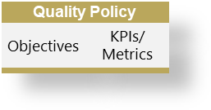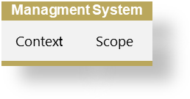

**Local Factors**

**Macro Environment**

**External Issues**

**Interested Parties**

**Internal Issues**

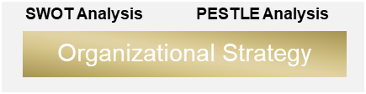

We analyze and monitor these factors to protect process stability and maintain the integrity of our quality management system (QMS).

Manufacturing Made Easy Ltd then monitors and reviews this information to ensure that a continual understanding of each relevant parties requirements is derived and maintained. To facilitate the understanding of our context, we regularly consider issues that influence our context during management review meetings and are conveyed via minutes and business planning documents.

| Internal Issues | External Issues |
| --- | --- |
| [Link to the Internal Issues](https://mfgeasy-my.sharepoint.com/:x:/g/personal/d_m_patil_mfgeasy_co_uk/Ee2J7pkXml9Iv672JiIijOABvixVGMgBmqvdXw2kGiEiJA?e=fWtfgn&nav=MTVfezAwMDAwMDAwLTAwMDEtMDAwMC0wMjAwLTAwMDAwMDAwMDAwMH0) | [Link to the External Issues](https://mfgeasy-my.sharepoint.com/:x:/g/personal/d_m_patil_mfgeasy_co_uk/Ee2J7pkXml9Iv672JiIijOABvixVGMgBmqvdXw2kGiEiJA?e=KE0qdE&nav=MTVfezAwMDAwMDAwLTAwMDEtMDAwMC0wMzAwLTAwMDAwMDAwMDAwMH0) |

The results of our context analysis help identify relevant risks and opportunities, as explained in Section 6.1.

While ISO 9001:2015 does not require documented context, Manufacturing Made Easy Ltd maintains supporting records, including:

1. Context Analysis Document
2. Analysis of business plans, strategies, and statutory and regulatory commitments;
3. Analysis of technology and competitors;
4. Economic reports from relevant business sectors;
5. Technical reports from technical experts and consultants;
6. SWOT analysis reports or schedules for internal issues;
7. PESTLE analysis reports or schedules for external issues;
8. Minutes of meetings (Management and design review minutes), process maps and reports, etc.

SWOT helps us assess internal strengths and weaknesses, while PESTLE evaluates external factors affecting growth and strategy.

* 1. Relevant Interested Parties

Manufacturing Made Easy Ltd understands that the needs and expectations of our interested parties can change over time. We focus only on those that are relevant to our operations and quality management system.

| Interested Parties | Needs & Expectations |
| --- | --- |
| [Link to the Interested Parties Form](https://mfgeasy-my.sharepoint.com/:x:/g/personal/d_m_patil_mfgeasy_co_uk/Ee2J7pkXml9Iv672JiIijOABvixVGMgBmqvdXw2kGiEiJA?e=CdTRBM&nav=MTVfezAwMDAwMDAwLTAwMDEtMDAwMC0wMTAwLTAwMDAwMDAwMDAwMH0) | [Link to the Needs & Expectations Form](https://mfgeasy-my.sharepoint.com/:x:/g/personal/d_m_patil_mfgeasy_co_uk/Ee2J7pkXml9Iv672JiIijOABvixVGMgBmqvdXw2kGiEiJA?e=CdTRBM&nav=MTVfezAwMDAwMDAwLTAwMDEtMDAwMC0wMTAwLTAwMDAwMDAwMDAwMH0) |

We identify and assess these needs to ensure our projects and processes meet all applicable relevant requirements. Where appropriate and relevant, we translate them into QMS requirements.

* 1. Quality Management System
     1. Management System Scope

Based on the analysis of the issues, needs and expectations identified in Sections 4.1 and 4.2, Manufacturing Made Easy Ltd has established the scope of our quality management system in order the implement our objectives and our policies that are relevant to our context, projects and any interested parties.

This document describes our quality management system, presents authorities, inter-relationships and responsibilities of process owners and personnel that operate within the system. We have decided to retain and update our quality manual, as our employees, customers, suppliers and other stakeholders perceive it to add value to our operations.

This document also demonstrates the relationship between our quality management system and the sequence and interaction of our key processes. Conformance to ISO 9001:2015 has been verified utilizing a formal assessment and review process by <name of Registrar (LRQA?)>.

* + 1. Management System Processes

Manufacturing Made Easy Ltd has implemented a quality management system that establishes, documents, and maintains our processes, quality policies, and objectives, in full compliance with the requirements of ISO 9001:2015.

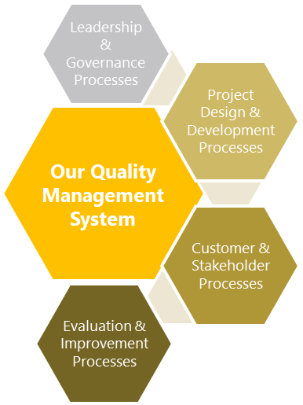

Figure 2 : Key Process Groups

We follow a process approach to manage and control activities, ensuring effective results. Our key process groups are:

* Leadership and planning
* Customer and stakeholder engagement
* Project design and development
* Evaluation and improvement

These processes are supported by tools such as procedures, process maps, and flow diagrams. See Appendix A.2 for an overview of how our processes interact.

Process effectiveness is measured through audits, inspections, and data analysis. We use key performance indicators (KPIs), along with risk and opportunity assessments, to monitor performance and drive improvement.

* + 1. Outsourced Processes

When Manufacturing Made Easy Ltd outsources processes that affect conformity, we apply controls such as verifying personnel competence, inspection, and adherence to design specifications (see Section 8.4).

These controls do not remove our responsibility to meet client, legal, or regulatory requirements. Instead, they help us manage risks and ensure supply chain reliability.

Outsourced processes are managed through contracts, purchase order, and may also be evaluated through audits and performance reviews.

* + 1. Documented Information
       1. Management System Documents

Manufacturing Made Easy Ltd maintains all documented information required by ISO 9001:2015 and any additional information needed to show our QMS is working effectively (see Register of Documented Information).

We control documented information if it:

* Communicates important messages
* Proves process or project conformity
* Confirms planned results were achieved
* Supports knowledge sharing

Should any of the above criteria apply, Manufacturing Made Easy Ltd ensures that this information is retained and/or maintained as a form of 'documented information'

* + - 1. Creating & Updating

Manufacturing Made Easy Ltd ensures all documented information is clearly identified (e.g. title, date, author) and available in the right format and media (e.g. paper or electronic).

All documents are reviewed and approved for suitability and accuracy.

* + - 1. Controlling Documented Information

Manufacturing Made Easy Ltd retains documented information to show compliance with ISO standards, customer requirements, and effective system operation.

Documents are managed using standard forms and stored on OneDrive, which is regularly updated and backed up to ensure only current versions are accessible.

Document control follows Procedure, which covers:

1. Document approval before issue;
2. Regular review and updates;
3. Clear version and revision tracking;
4. Access to current documents at point of use;
5. Legibility and easy identification;
6. Control of documents from external sources;
7. Prevention of outdated document use;

Supporting documentation:

|  |  |
| --- | --- |
| Ref. | Title & Description |
| 01 | Documented Information Procedure |

1. Leadership & Governance
   1. Leadership & Commitment
      1. Quality Management

Manufacturing Made Easy Ltd’s leadership is responsible for implementing the QMS, including the quality policy, objectives, and project plans focused on customer needs.

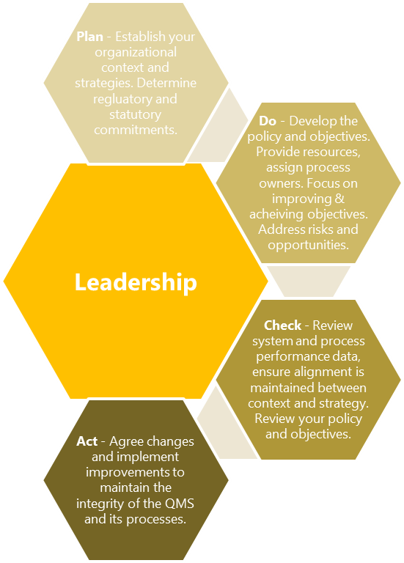

Figure 3: Leadership PDCA Cycle

Top management defines strategic direction, assigns responsibilities, and ensures effective communication and performance.

We support the creation of processes needed to meet quality objectives and regularly verify QMS effectiveness through internal audits and performance analysis. Annual management reviews assess the system and drive improvements.

Our leadership ensures that policies and objectives are understood and applied at all levels through communication, training, and performance reviews. This helps:

1. Promote fairness, trust, and ethical behavior;
2. Encourage a quality-focused culture;
3. Empower employees with resources and accountability;
4. Recognize contributions across the team.
   * 1. Customer Focus

Manufacturing Made Easy Ltd is committed to understanding and meeting customer needs and exceeding expectations.

Top management reviews customer satisfaction goals and ensures customer requirements are clearly understood, communicated, and met. Feedback and complaints are monitored to identify improvement opportunities, and we actively engage with customers to stay aligned with their needs.

* + 1. Quality Policy
       1. Establishing & Communicating

The quality policy provides direction for setting performance goals and objectives. It is established by top management, documented, and made available to interested parties, including on our website.

The Quality Manager is responsible for maintaining the policy in consultation with top management. It is reviewed annually or as needed, based on:

1. Changing needs of interested parties (Section 4.2)
2. Risks and opportunities (Section 6.1)

The policy is communicated to all employees through training, internal communications, and performance reviews. Understanding is checked through audits and other methods.

* + - 1. Quality Policy Statement

Manufacturing Made Easy Ltd is committed to open communication, integrity, fairness, and responsibility to our employees, customers, and communities. Our vision is to exceed customer expectations in quality, cost, delivery, and value, while building a profitable and ethical business.

**OUR PEOPLE**  
We value diversity, fairness, and equal opportunity. We are committed to:

* A culture of honesty and integrity
* Fair sharing in company success
* Empowerment through training and communication
* Personal growth and safety in the workplace

**OUR CUSTOMERS**  
Customer needs are our top priority. We aim to understand and respond to their requirements promptly and honestly.

**OUR COMMUNITY**  
We support the communities where we operate, promote social responsibility, protect the environment, and comply with all legal and regulatory requirements.

**OUR QUALITY**  
We clearly define customer expectations and strive to meet or exceed them. We follow all relevant standards to ensure consistent quality and continuous improvement.

* 1. Role, Responsibilities & Authorities

The organizational structure of Manufacturing Made Easy Ltd is shown in Appendix A.3. The chart outlines reporting lines, and job descriptions define roles and responsibilities. These are reviewed by top management as needed based on changing requirements and risks.

Top management is responsible for the overall quality of our design and development services. This includes planning, setting objectives, providing resources, overseeing the QMS, and conducting management reviews.

Responsibilities assigned to management teams include:

1. Ensuring QMS processes achieve intended results;
2. Reporting on QMS performance and identifying opportunities;
3. Driving continual improvement;
4. Promoting customer focus;
5. Managing and maintaining system integrity during changes;
6. Communicating roles and responsibilities clearly.

All employees contribute to QMS effectiveness by participating in audits, supporting improvements, and taking ownership of their work. They are responsible for:

* Following policies and procedures;
* Meeting operational objectives;
* Identifying and reporting issues;
* Supporting corrective and preventive actions.
  1. Communication
     1. Internal Communication

Manufacturing Made Easy Ltd shares QMS information internally through training, audit reports, and improvement activities. Management and employees are responsible for regular communication to highlight the importance of each person’s role—often shared in team settings.

Employee contributions toward objectives are also discussed during performance reviews.

QMS topics communicated internally may include:

1. Day-to-day operations and general awareness;
2. Quality policy;
3. Information on achieving objectives and targets;
4. Risk and opportunities.

Top management is responsible for communicating company policies and the importance of meeting customer and regulatory requirements. They ensure the quality policy is understood and applied by setting clear goals.

Internal communication is ongoing and delivered through various methods as needed.

1. Regular meetings and briefings;
2. Training sessions and training material;
3. Display boards, memorandums, letters;
4. Website, intranet, internal e-mails, shared drive;
5. Project design and development and process performance data analysis and audit results;
6. Targets, objectives, scorecards, KPIs, management system manual and procedures;
7. Corrective action and non-conformance reports;
8. Minutes of ad-hoc and scheduled meetings.
   * 1. External Communication

Manufacturing Made Easy Ltd identifies when it is necessary to share QMS-related information with external interested parties (see Section 4.2). These parties—such as customers, stakeholders, or the community—often influence our decision to implement and maintain the QMS.

External communication may include various methods, as appropriate.

| Interested Parties | Needs & Expectations | Possible modes of Communication |
| --- | --- | --- |
| Customers | Price, reliability & value | Publications in the media (LinkedIn) and focus groups |
| Owners | Profitability & growth | Annual reports or newsletters of performance |
| Suppliers/Provider | Beneficial relationships | Publications on our website, meetings or questionnaires |
| Regulatory Bodies | Compliance & reporting | Regulatory compliance submissions or results of audits |

Manufacturing Made Easy Ltd ensures all external communications are approved before release. When needed, guidance is sought on the content and method of communication.

Responses sent by email or letter are recorded and managed as documented information.

1. Management System Planning

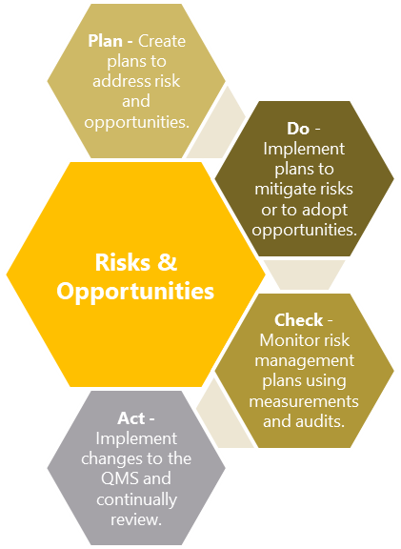

Figure 4: Risk & Opportunities PDCA Cycle

* 1. Addressing Risks & Opportunities

The aim of risk and opportunity management at Manufacturing Made Easy Ltd is to ensure efficient use of resources to make the most of opportunities and reduce risks.

This is achieved by:

1. Providing sufficient resources for risk and opportunity management;
2. Assigning responsibilities and authorities for related activities;
3. Reviewing outcomes from audits and risk assessments.

The process includes assessing internal and external issues (Section 4.1) and considering the needs and expectations of interested parties (Section 4.2). Risk and opportunity management is embedded into day-to-day operations.

Manufacturing Made Easy Ltd has classified its ‘risk appetite’ as the amount of risk that we are willing to accept in pursuit of an opportunity or the avoidance of risk where each pertains to project and/or system conformity, and which reflect the following considerations:

1. Risk management philosophy per project or process;
2. Capacity to take on or mitigate risk;
3. Our objectives, business plans and respective stakeholder demands;
4. Evolving industry and market conditions;
5. Tolerance for failures.

Manufacturing Made Easy Ltd uses registers to help record, assess, respond, review, report, monitor and plan for the risks and opportunities that we perceive to be relevant. The registers allow our organization to methodically assess each risk and to study each opportunity associated with our organizational context, and the needs and expectations of our interested parties. The register records the controls and treatments of risks and opportunities and preserves this knowledge as documented information.

Supporting documentation:

|  |  |
| --- | --- |
| Ref. | Title & Description |
| 02 | Risk & Opportunities Management Procedure |

* 1. Quality Objectives

Manufacturing Made Easy Ltd sets and reviews its objectives and targets regularly during management reviews. These are aligned with our quality policies, business needs, and the expectations of interested parties (Section 4.2).

When setting objectives, we consider technological, financial, and operational factors. Progress is tracked through key performance indicators (KPIs), which may include:

1. Turnover and profitability
2. Sales and project efficiency
3. Rejects, rework, and cost of quality
4. Staffing breakdown

On the basis of the set quality policies and in connection with the application of ISO 9001 quality management principles, Manufacturing Made Easy Ltd sets quality objectives that are specified in the register of objectives. All employees are responsible for fulfillment of the quality policies and subsequent objectives.

| Quality Objective | Target | Measure |
| --- | --- | --- |
| Implement ISO 9001:2015 | Achieve certification by Q2 2025 | ISO 9001 certificate |
| Implement training programme | All employees trained by Q1 2025 | Feedback, improved performance |
| Reduce customer complaints | Reduce returns by 10% | Increased % of 1st time acceptance |

* 1. Planning for Change

The quality management system (QMS) at Manufacturing Made Easy Ltd is planned and implemented to meet our business objectives and the requirements of ISO 9001:2015. This includes setting policies, objectives, and related procedures.

This document outlines our approach to establishing, maintaining, and improving the QMS. All planning outputs are documented, and changes are controlled.

When changes are made to the QMS, affected personnel are informed, and implementation is monitored to ensure effectiveness. Management reviews and internal audits help maintain system integrity during significant changes.

1. Support
   1. Resources
      1. General

Manufacturing Made Easy Ltd provides the necessary resources to implement, manage, and improve the quality management system. These include people, skills, infrastructure, technology, work environment, and finances.

Resource needs are defined in our procedures, work instructions, and relevant QMS sections, including:

1. Planning (Section 6.0)
2. Management Review (Section 9.3)
3. Human Resources (Section 7.1.2)
4. Infrastructure (Section 7.1.3)
5. Work Environment (Section 7.1.4)
6. Project Planning (Section 8.1)
7. Customer Requirements (Section 8.2)

Human resources are managed by Top Management.

* + 1. People

Manufacturing Made Easy Ltd ensures personnel are competent through clear job descriptions that define required qualifications, skills, and experience. Training is provided where needed to meet these requirements.

Qualifications are reviewed at hiring, during role changes, or when job requirements change. If gaps are found, appropriate training or actions are taken, and their effectiveness is evaluated.

All employees are made aware of how their work supports company objectives. A formal system ensures staff are properly trained for their roles.

The CEO maintains training and qualification records, including certificates, job descriptions, and CVs, and reviews them to identify future training needs.

* + - 1. Competence

Top management identifies new competency needs during management reviews. These are used to update job descriptions and guide recruitment.

Training is provided in-house or maybe through external courses, depending on the skill required. Training effectiveness is evaluated and recorded.

New staff receive an induction covering company policies and objectives. Future training needs are reviewed during the management reviews meeting.

* + - 1. Awareness

All employees are trained on how their work supports the company’s policies and objectives. A formal system ensures they are properly trained for their roles.

Awareness training is provided in-house, maybe with external courses used for specialist skills. Training effectiveness is evaluated and recorded.

New employees receive an induction covering company policies and objectives. Future training needs are reviewed during management reviews.

Supporting documentation:

|  |  |
| --- | --- |
| Ref. | Title & Description |
| 03 | Competence & Awareness Procedure |

* + 1. Infrastructure

Manufacturing Made Easy Ltd is responsible for planning, providing and maintaining the resources needed to achieve project and process conformance, including buildings, workspace and associated utilities; process equipment (hardware and software); and supporting services (such as material handling systems and communications systems). The CEO and Senior Engineer are overall responsibility for managing our facilities and equipment maintenance programs which include:

1. Material handling equipment management, maintenance and repair;
2. Process and projection equipment management, maintenance and repair;
3. Facilities management, maintenance and repair.
   * 1. Operational Environment

Manufacturing Made Easy Ltd ensures that offices and labs meet health and safety regulations. The Senior Engineer conducts annual audits to maintain compliance.

Top management is committed to providing:

* A safe workplace, equipment, and working methods
* Training and supervision for employees
* Safe handling and storage of materials and equipment
* A safe, well-lit, and ventilated working environment
  + 1. Monitoring & Measurement Tools

Manufacturing Made Easy Ltd identifies the monitoring and measurement activities needed to ensure results meet specified tolerances. The frequency of calibration and maintenance is based on process risk.

To ensure valid results, equipment is:

1. Calibrated or verified before use or at set intervals
2. Calibrated against traceable standards
3. Protected from damage and improper adjustments
4. Clearly identified with calibration status
5. Removed from use if out of calibration, and results are revalidated
6. Adjusted as needed

If equipment is found out of calibration, the Quality Manager reviews the impact on previous results and takes necessary action. Any affected equipment or projects are addressed, and all calibration and validation records are maintained.

Supporting documentation:

|  |  |
| --- | --- |
| Ref. | Title & Description |
| 04 | Calibrated Equipment Procedure |

* + 1. Organisational Knowledge

Manufacturing Made Easy Ltd values organizational knowledge as essential for maintaining quality and ensuring consistent project and service delivery. It is closely linked to employee competence—the ability to apply knowledge effectively.

To retain and share knowledge, we record it as documented information and embed it into our processes. Examples include but not limited to:

1. Process and project documentation
2. Past specifications and work instructions
3. Experience of skilled staff
4. Knowledge of relevant technologies and infrastructure

Sources of internal knowledge also include our intellectual property; knowledge gained from experience and coaching; lessons learnt from failures and successes; capturing and sharing undocumented knowledge and experience; the results of improvements in processes, projects and services.

We gather knowledge from both internal and external sources, including but not limited to:

1. Lessons learned from non-conformities and improvements
2. Feedback from customers, suppliers, and partners
3. Mentoring and succession planning
4. Industry events, research, and benchmarking
5. Product & Service Development
   1. Operational Planning & Control

Manufacturing Made Easy Ltd establishes and implements documented plans and procedures that describe the processes (Refer to Section 4.3.2) and the controls required for the provision of projects and services in cognizance to the objectives, the potential for planned or unintended change, and the risks and opportunities identified in Section 6.1. During this planning phase, management or other responsible personnel identify the following parameters:

* Objectives and requirements for the project or service;
* Verification, validation, monitoring, inspection and test requirements;
* Documented information to demonstrate conformity;
* Document information to demonstrate process effectiveness;
* Necessary resources; or outsourced processes and their controls;
* Criteria for process performance and project/service acceptance;
* Potential consequences and mitigation to change affecting input requirements;
* Resources necessary to support the ongoing operation and maintenance of the project.

The output of planning activity includes documented plans, resource schedules, processes, equipment requirements, procedures and design outputs.

* 1. Customer Requirements
     1. Customer Communication

Manufacturing Made Easy Ltd considers effective customer communication essential to customer satisfaction. Clear and timely communication helps prevent and resolve issues.

Communication can take place through below listed channels:

1. Project brochures, specifications, and data sheets
2. Enquiries, quotes, orders, invoices, and credit notes
3. Project confirmations and amendments
4. Project Delivery notes and certificates of conformity
5. Emails, letters, and general correspondence
6. Handling of customer property
7. Customer feedback and complaints

The CEO and Senior Engineer are responsible for establishing methods of communication with our customers to ensure enquiries, contracts or project handling; including amendments, customer feedback and complaints are handled expeditiously and professionally.

* + 1. Determining Requirements

Manufacturing Made Easy Ltd ensures customer, stakeholders and interested parties needs and expectations are clearly understood before accepting any order. This includes:

1. Previous customer requirements which pertain to current project;
2. Statutory and regulatory requirements related to the project;
3. Other non-customer specified performance requirements;
4. Any additional requirements determined by Manufacturing Made Easy Ltd;
5. Requirements not stated by the customer but which are necessary for specified or intended use.

This is customer-driven process requires clear, and often repeated, customer interaction to understand the customer’s needs.

* + 1. Review of Requirements

Prior to committing to the customer, Manufacturing Made Easy Ltd ensures and confirms our capacity to supply the requirements for project. Pre-acceptance reviews are conducted to ensure that:

1. Project requirements are defined;
2. Requirements are defined for delivery;
3. Requirements not stated by the customer but which are necessary for intended use are appropriate;
4. Any additional requirements determined by Manufacturing Made Easy Ltd are appropriate;
5. Contract or product requirements differing from those previously expressed are resolved;
6. Manufacturing Made Easy Ltd has the ability to meet the defined requirements;
7. Documented information is retained and maintained showing the results of the review.

Customer requirements are confirmed before acceptance by the exchange of contracts, purchase orders via appropriate electronic or hard copy formats.

* + 1. Changes in Requirements

Manufacturing Made Easy Ltd ensures that all relevant documented information; relating to changes in project requirements, is authorized by senior engineer and amended where necessary, and that all relevant personnel are made aware of the documented requirement changes.

* 1. Design & Development
     1. General

Manufacturing Made Easy Ltd follows a controlled and documented design and development process to transform input requirements into project or service outputs.

Design activities are planned, reviewed, and, where needed, validated. Outputs are verified before release. Reviews may include code checks, peer reviews, or independent assessments to manage risk and ensure quality.

* + 1. Planning

At the start of each project, Manufacturing Made Easy Ltd reviews the requirements and defines the key stages of the process, including task sequence and configuration control.

Where needed, we consider:

1. Assigning roles and responsibilities
2. Scheduling design reviews
3. Verification and validation at each stage
4. Assessing project complexity and duration
5. Identifying required resources
6. Managing communication between involved personnel
7. Involving customers or users as needed
8. Defining follow-up requirements for project delivery
9. Setting control levels based on customer expectations
10. Documenting evidence to show requirements are met

Design tasks are broken down into clear elements, with input data reviewed to ensure alignment with customer requirements.

* + 1. Inputs

Design inputs such as customer data, drawings, specifications, standards, regulations, etc. are checked to confirm they are adequate and unambiguous. Any conflicting or ambiguous requirements are discussed and resolved with the originator and the outcome retained as documented information. Manufacturing Made Easy Ltd also considers the following:

1. Functional and performance requirements;
2. Information derived from previous, similar designs;
3. Statutory and regulatory requirements;
4. Commitments to implement any standards or codes practice;
5. Consequences of failure due to the nature of the projects or services.

If the project involves modifying an existing company design then the impact of the changes on component parts, stocks and delivered projects is also evaluated.

* + 1. Controls

Manufacturing Made Easy Ltd controls the design and development process to ensure defined results are achieved and corrective actions are taken when issues arise during reviews, verification, or validation.

Designs are verified by comparing with proven designs or performing calculations to confirm input requirements are met. Verification is part of the design review process, and results are documented.

Validation ensures that the final project or service meets the intended use or application before delivery. If full validation isn’t possible before delivery, partial validation is performed as applicable.

When testing is required, it is planned, reviewed, and documented to confirm:

1. The correct configuration is tested
2. Test procedures are followed
3. Acceptance criteria are met

Design reviews are conducted at key stages to:

1. Confirm requirements are met
2. Identify issues and define corrective actions
3. Approve progression to the next stage

All reviews include relevant stakeholders, and decisions are recorded.

* + 1. Outputs

Design and development outputs are documented and may include requirements, calculations, and analysis that can be verified against inputs. Outputs meet design requirements, include acceptance criteria, and provide the necessary details for safe and proper use.

* + 1. Changes

Manufacturing Made Easy Ltd documents all design changes made during or after development. Changes are reviewed, verified, validated, and approved. We also assess any potential impact on projects already delivered.

Supporting documentation:

|  |  |
| --- | --- |
| Ref. | Title & Description |
| 05 | Design & Development Procedure |

* 1. Control of Suppliers & External Processes
     1. General

Manufacturing Made Easy Ltd ensures that all purchased products or services meet specified requirements. We work closely with suppliers and monitor their performance through audits, inspections, and data analysis.

The level of control depends on the impact the purchased item has on the final project. Key considerations include:

1. Ensuring that we understand the capabilities and competencies of potential outsourcing suppliers;
2. Ensuring that we clearly communicate the roles and responsibilities of the outsourcing supplier;
3. Defining the quality requirements for the outsourced process, activity, or project;
4. Establishing upfront the criteria for and review of deliverables, frequency of inspections and audits;
5. Selecting and qualifying appropriate outsourcing suppliers.

Employees are responsible for evaluating and selecting suppliers based on their ability to meet requirements. Evaluation criteria and records are maintained as outlined in the Purchasing & Procurement Procedure.

* + 1. Purchasing Controls

Manufacturing Made Easy Ltd checks purchased items against the purchase order for identity and quantity. Accepted items are stored; rejected items are recorded via a non-conformance report, and the supplier is contacted for replacement or credit.

Purchased items may be inspected to ensure they meet:

1. Purchase orders and delivery notes;
2. Project specifications;
3. National or international standards.

Where needed, risk control measures are included in purchasing data and clearly communicated to suppliers.

* + 1. Purchasing Information

Manufacturing Made Easy Ltd uses purchase orders to specify the projects or services to be purchased. Authorized employees prepare and review them to ensure requirements are clear before release.

Each purchase order may include:

* Identification of project or service to be delivered, quantity, delivery date, and cost;
* Requirements for approval or qualification of project, procedures, processes or equipment;
* Requirements of the quality management system and the qualification of personnel.

When needed, supplier responsibilities for risk management and specific risk controls are included and clearly communicated.

Supporting documentation:

|  |  |
| --- | --- |
| Ref. | Title & Description |
| 06 | Purchasing & Procurement Procedure |

* 1. Release of Projects & Services

The Quality Manager is responsible for planning and managing inspections and tests to ensure project requirements are met at each stage.

Projects are not used until verified, unless temporarily released under controlled conditions pending final checks.

If sampling is used for inspection, the plan is statistically valid and prevents acceptance of nonconforming items. Customer approval is obtained if required.

Project release is authorized only after all planned checks are completed, unless approved by management or the customer. Records of authorization and acceptance criteria are maintained, including:

* Criteria for acceptance and rejection;
* Locations in the process sequence where measurement and testing operations were performed;
* Types of measurement instruments used, including any instructions associated with their use;
* Test records showing actual test results where required by the specification or acceptance test plan.
  1. Control of Non-conforming Outputs

Manufacturing Made Easy Ltd identifies and controls nonconforming outputs to prevent unintended use or delivery. The issue is analyzed, and root causes are investigated.

Corrective actions are taken to prevent recurrence, and the output is rechecked for conformity. Records of nonconformities, responsible authorities, actions taken, and any approved concessions are maintained.

Supporting documentation:

|  |  |
| --- | --- |
| Ref. | Title & Description |
| 07 | Non-conforming & Corrective Action Procedure |

1. Performance Evaluation
   1. Monitoring, Measurement, Analysis & Evaluation
      1. General

Manufacturing Made Easy Ltd determines what aspects of the QMS and processes need to be monitored, measured, and evaluated. Frequency and methods are based on:

1. Statutory and regulatory requirements;
2. Customer feedback and specification requirements;
3. Process and QMS requirements;
4. Process performance and audit results;
5. Level of risk and types of control measure;
6. Trends in non-conformities or corrective actions;
7. Criticality for project conformity.

Monitoring results are documented and analyzed to assess effectiveness and identify improvements.

1. Provision is made for the identification and resolution of non-conformances;
2. The emphasis is to prevent any problems which might affect customer satisfaction;
3. Where specific inspection points are required these are identified at the contract planning phase.

Test and inspection records are kept for at least three years. Project samples are stored for five years.

Projects are only released after all inspections and tests are complete, unless specially authorized under controlled conditions by the Quality Manager and, if needed, the customer.

* + 1. Customer Satisfaction

The Quality Manager monitors customer feedback to assess whether customer requirements are being met. Complaints are forwarded to the Senior Engineer and, if unresolved, escalated to the CEO.

Customer feedback—surveys, complaints, and forms—is reviewed, and corrective actions are taken as needed. Satisfaction is tracked using:

1. Project returns and warranty claims;
2. Repeat customers and trends in market share;
3. Analysis of customer complaints and customer satisfaction surveys;
4. Recognition and consumer awards.

Supporting documentation:

|  |  |
| --- | --- |
| Ref. | Title & Description |
| 08 | Customer Satisfaction Procedure |

* + 1. Analysis and Evaluation

Top management use data and statistical tools to assess the effectiveness of QMS processes and identify improvement opportunities. At a minimum, data is analyzed to evaluate progress toward objectives and customer satisfaction.

A process is considered effective when it consistently delivers the desired results. Effectiveness is measured by:

* Project quality and accuracy
* Delivery and cost performance
* Employee performance
* Customer satisfaction

Manufacturing Made Easy Ltd monitors trends using:

1. Characteristics of processes, projects and their trends;
2. Conformity to project, customer and legal requirements;
3. Customer satisfaction and perception data;
4. Supplier and external provider performance data;
5. Results of actions taken to address risks and opportunities;
6. Effective implementation of QMS planning;
7. Improvement opportunities identified during internal audits and management reviews;

Performance limits are defined as objectives. Corrective action is taken if trends approach these limits. Employees using statistical tools are trained and competent.

* 1. Internal Audit

Internal audits help assess the effectiveness of Manufacturing Made Easy Ltd’s quality management system. Audits are planned and based on risk and continual improvement principles, ensuring alignment with ISO 9001:2015.

The audit program considers the importance and performance of each process. Audit frequency depends on past results, customer satisfaction, nonconformities, and other key factors.

Each audit follows a defined scope, criteria, and method. Trained auditors are selected to ensure objectivity. Auditors:

1. The results of each are reported to the Quality Manager;
2. That timely appropriate corrective action undertaken where required;
3. They retain documented information such as audit checklists and audit reports as evidence of the effective implementation of the audit programme in respect of each audit.

Supporting documentation:

|  |  |
| --- | --- |
| Ref. | Title & Description |
| 09 | Internal Audit Procedure |

* 1. Management Review
     1. General

Top management conducts annual management review meetings to ensure the QMS remains suitable, effective, and aligned with company strategy.

* + 1. Inputs

Key inputs include data from conformance and performance measurements across processes. Improvement recommendations are based on this evaluation.

Conformance is verified through internal audits and our ability to detect and correct issues. Performance is assessed by reviewing progress toward corporate and operational objectives.

* + 1. Outputs

Management review meetings result in actions to improve the QMS. These may relate to:

1. QMS and process effectiveness
2. Meeting customer requirements
3. Risks and opportunities
4. Resource needs

Actions, responsibilities, and deadlines are assigned and documented in the meeting minutes.

Supporting documentation:

|  |  |
| --- | --- |
| Ref. | Title & Description |
| 10 | Management Review Procedure |

1. Improvement
   1. General

Manufacturing Made Easy Ltd identifies and implements improvement opportunities to meet customer and stakeholder needs and enhance satisfaction. This is driven by data analysis, including:

1. Risk and opportunity evaluations;
2. Assessment of the changing needs and expectations of interested parties;
3. The conformity of existing projects and services;
4. The effectiveness of our QMS;
5. Supplier performance;
6. Levels of customer satisfaction, including complaints and feedback;
7. Internal and external audit results;
8. Corrective action and non-conformance rates;
9. Data from process and project characteristics and their trends.

Opportunities for improvement from analysis of longer-term data and trends are evaluated and implemented through the management review process and are prioritized with respect to their relevance for achieving our quality objectives.

The overall effectiveness of continual improvement program (including corrective actions taken as well as the overall progress towards achieving corporate level improvement objectives) is assessed through our management review process.

* 1. Non-conformity & Corrective Action

Manufacturing Made Easy Ltd uses evidence of non-conformance, customer complaints, or process issues to drive continual improvement. Problems are corrected promptly, and root causes are investigated to prevent recurrence.

All employees are responsible for corrective actions are notified of non-conformities. Actions taken are appropriate to the impact of the issue.

The Corrective Action Procedure outlines how we:

1. Reviewing non-conformities, including customer complaints and project returns;
2. Determining the causes of project non-conformities and process deficiencies;
3. Evaluating the need for action to ensure that non-conformities do not recur;
4. Determining and implementing action needed;
5. Recording and reviewing the results of actions taken.

Follow-up audits ensure actions are effective. The Quality Manager analyzes trends and reports results to top management for further improvement or QMS updates.

Corrective actions are considered effective if the issue is resolved and does not recur. All actions and outcomes are documented.

Supporting documentation:

|  |  |
| --- | --- |
| Ref. | Title & Description |
| 07 | Non-conforming & Corrective Action Procedure |

* 1. Improvement

Manufacturing Made Easy Ltd improves its quality management system through policies, objectives, audits, data analysis, corrective actions, and management reviews.

Improvement starts with setting corporate objectives. Performance data, audit results, customer feedback, and quality costs are reviewed against these objectives to find opportunities for improvement.

The effectiveness of improvements and progress toward objectives are evaluated during management reviews.

Appendices

A.1 Correlation Matrix

This section provides a matrix to correlate the requirements of ISO 9001:2015 against the relevant sections in this document and should be used to determine where the new and amended clauses are located.

| ISO 9001:2015 | | This Document | |
| --- | --- | --- | --- |
| 4.0 | Context of the Organization | 4.0 | About our Organization |
| 4.1 | Understanding the Organization and its Context | 4.1 | Organizational Context |
| 4.2 | Needs and Expectations of Interested Parties | 4.2 | Relevant Interested Parties |
| 4.3 | Scope of the Quality Management System | 4.3.1 | Management System Scope |
| 4.4 | Quality Management Systemand its Processes | 4.3.2 | Management System Processes |
| 5.0 | Leadership | 5.0 | Leadership & Governance |
| 5.1 | Leadership and Commitment | 5.1 | Leadership & Commitment |
| 5.1.1 | Quality Management System | 5.1.1 | Quality Management System |
| 5.1.2 | Customer Focus | 5.1.2 | Customer Focus |
| 5.2 | Quality Policy | 5.1.3 | Quality Policy |
| 5.2.1 | Establishing the Quality Policy | 5.1.3.1 | Establishing the Quality Policy |
| 5.2.2 | Communicating the Quality Policy | 5.1.3.2 | Communicating the Quality Policy |
| 5.3 | Roles, Responsibilities and Authorities | 5.2 | Roles, Responsibilities & Authorities |
| 6.0 | Planning for the Quality Management System | 6.0 | Management System Planning |
| 6.1 | Actions To Address Risks and Opportunities | 6.1 | Addressing Risk & Opportunities |
| 6.2 | Quality Objectives & Planning To Achieve Them | 6.2 | Quality Objectives |
| 6.3 | Planning of Changes | 6.3 | Planning for Change |
| 7.0 | Support | 7 | Support |
| 7.1 | Resources | 7.1 | Resources |
| 7.1.1 | General | 7.1.1 | General |
| 7.1.2 | People | 7.1.2 | People |
| 7.1.3 | Infrastructure | 7.1.3 | Infrastructure |
| 7.1.4 | Environment for the Operation Of Processes | 7.1.4 | Operational Environment |
| 7.1.5 | Monitoring and Measuring Resources | 7.1.5 | Monitoring and Measuring Tools |
| 7.1.6 | Organizational Knowledge | 7.1.6 | Organizational Knowledge |
| 7.2 | Competence | 7.1.2.1 | Competence |
| 7.3 | Awareness | 7.1.2.2 | Awareness |
| 7.4 | Communication | 5.3 | Communication |
| 7.5 | Documented Information | 4.3.4 | Documented Information |
| 7.5.1 | General | 4.3.4.1 | Management System Documents |
| 7.5.2 | Creating and Updating | 4.3.4.2 | Creating and Updating |
| 7.5.3 | Control of Documented Information | 4.3.4.3 | Controlling Documented Information |
| 8.0 | Operation | 8.0 | Project & Service Development |
| 8.1 | Operational Planning and Control | 8.1 | Operational Planning and Control |
| 8.2 | Requirements for Projects and Services | 8.2 | Customer Requirements |
| 8.2.1 | Customer Communication | 8.2.1 | Customer Communication |
| 8.2.2 | Determining Requirements Related to Projects | 8.2.2 | Determining Requirements |
| 8.2.3 | Review of Requirements Related to the Projects | 8.2.3 | Review of Requirements |
| 8.2.4 | Changes to Requirements for Projects/Services | 8.2.4 | Changes in Requirements |
| 8.3 | Design and Development of Projects | 8.3 | Design and Development of Projects |
| 8.3.1 | General | 8.3.1 | General |
| 8.3.2 | Design and Development Planning | 8.3.2 | Planning |
| 8.3.3 | Design and Development Inputs | 8.3.3 | Inputs |
| 8.3.4 | Design and Development Controls | 8.3.4 | Controls |
| 8.3.5 | Design and Development Outputs | 8.3.5 | Outputs |
| 8.3.6 | Design and Development Changes | 8.3.6 | Changes |
| 8.4 | Externally Provided Projects & Services | 8.4 | Control of Suppliers & External Processes |
| 8.4.1 | General | 8.4.1 | General |
| 8.4.2 | Type & Extent of Control of External Provision | 8.4.2 | Purchasing Controls |
| 8.4.3 | Information for External Providers | 8.4.3 | Purchasing Information |
| 8.6 | Release of Projects and Services | 8.5 | Release of Projects and Services |
| 8.7 | Non-conforming Process Outputs and Projects | 8.6 | Control of Non-conforming Outputs |
| 9.0 | Performance Evaluation | 9.0 | Performance Evaluation |
| 9.1 | Monitoring, Measurement, Analysis & Evaluation | 9.1 | Monitoring, Measurement, Analysis & Evaluation |
| 9.1.1 | General | 9.1.1 | General |
| 9.1.2 | Customer Satisfaction | 9.1.2 | Customer Satisfaction |
| 9.1.3 | Analysis and Evaluation | 9.1.3 | Analysis and Evaluation |
| 9.2 | Internal Audit | 9.2 | Internal Audit |
| 9.3 | Management Review | 9.3 | Management Review |
| 9.3.1 | General | 9.3.1 | General |
| 9.3.2 | Management Review Inputs | 9.3.2 | Inputs |
| 9.3.3 | Management Review Outputs | 9.3.3 | Outputs |
| 10.0 | Improvement | 10.0 | Improvement |
| 10.1 | General | 10.1 | General |
| 10.2 | Non-Conformity and Corrective Action | 10.2 | Non-Conformity & Corrective Action |
| 10.3 | Continual Improvement | 10.3 | Continual Improvement |

A.2 Sequence & Interaction of Processes

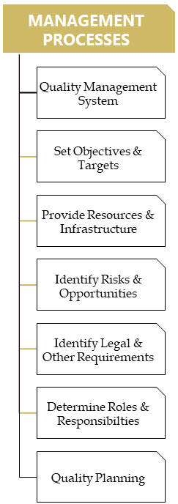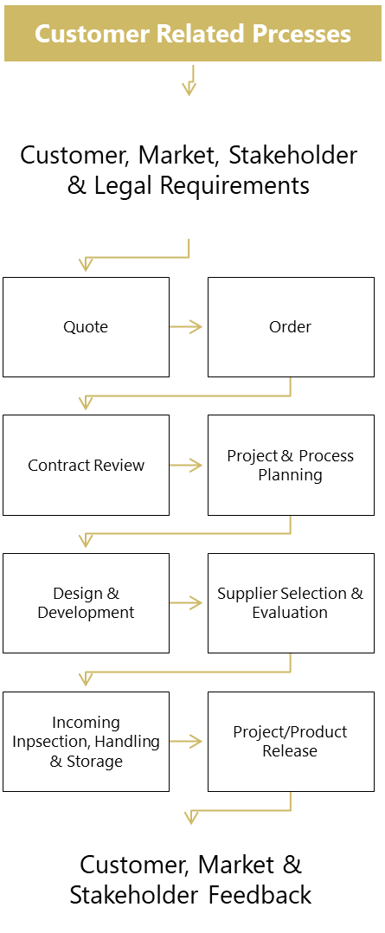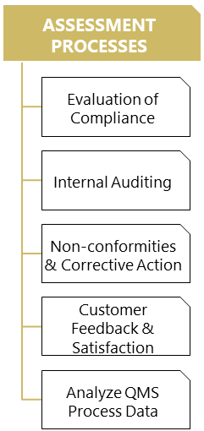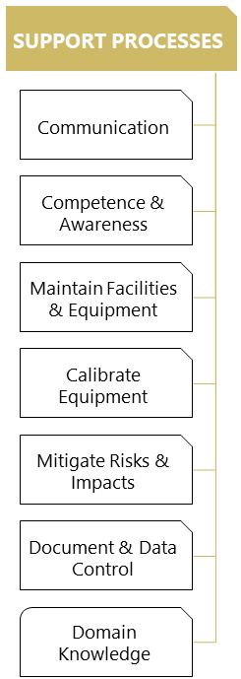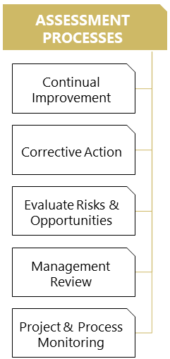

A.3 Organization Chart

[Organization chart Document](https://mfgeasy-my.sharepoint.com/:w:/g/personal/d_m_patil_mfgeasy_co_uk/EbbTam13qZxEiruHLeptrFUBH4TcdvtBPfbNAtw91rOl3g)